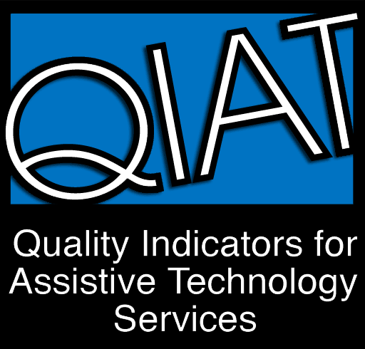
Implementation of Assistive Technology Planner

Teams may use this form to guide discussion in the development of an implementation plan which is well thought-out with input from all stakeholders (team). Best practices suggest that all components below should be considered when developing the AT implementation plan.

Key Elements of an AT Implementation Plan
Who will collaborate in the development of the implementation plan?

What specific goals and tasks will be addressed in the plan?

What aspects of the student’s performance are expected to change (e.g., reduced time, increased accuracy, quantity, quality, engagement)?

How will AT be integrated into the curriculum and daily activities across environments?

What tools and strategies will be used to accomplish identified task(s)?

What evidence/data will be needed to determine which tools and strategies are most effective for particular environments and tasks?

How will performance evidence/data be measured and collected?

When will the performance evidence/data be reviewed to determine what changes, if any, are needed in the implementation plan?

What do team members need to do for successful implementation to take place?

Which team members will share responsibility for each action that needs to be taken (e.g., staff, family, supporters, student)?

What initial and ongoing learning opportunities will be provided for all team members, including the student?

How will equipment and materials be managed and maintained?

